SAI VIDYA INSTITUTE OF TECHNOLOGY
(Affiliated to Visvesvaraya Technological University, Belagavi | Recognized by Govt. of Karnataka | Approved by AICTE, New Delhi)
Rajanukunte, Bengaluru- 560 064

DEPARTMENT OF COMPUTER SCIENCE AND ENGINEERING
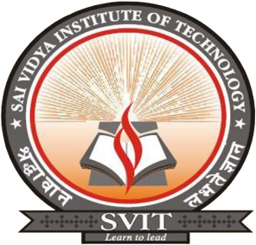

CERTIFICATE

Certified that the Project work entitled “Sign Language Recognition” carried out by Mr. Satwik Ram K (1VA17CS047), Mr. N Pavan Kumar (1VA17CS028), a bonafide students of SAI VIDYA INSTITUTE OF TECHNOLOGY, Bengaluru, in partial fulfillment for the award of Bachelor of Engineering in Computer Science and Engineering of VISVESVARAYA TECHNOLOGICAL UNIVERSITY, Belagavi during the year 2020-21. It is certified that all corrections/suggestions indicated for Internal Assessment have been incorporated in the Report deposited in the departmental library. The Project report has been approved as it satisfies the academic requirements in respect of Project work prescribed for the said Degree.

Guide Name  Designation,  Dept. of CS&E, SVIT | Prof. Sreelatha P K  HOD,  Dept. of CS&E, SVIT | Dr. H S Ramesh Babu  Principal,  SVIT

External Viva:

Name | Signature
- ___________________________ | __________________________
- ___________________________ | __________________________

